Jaktkart for Vestre Brandbu Grunneierforening
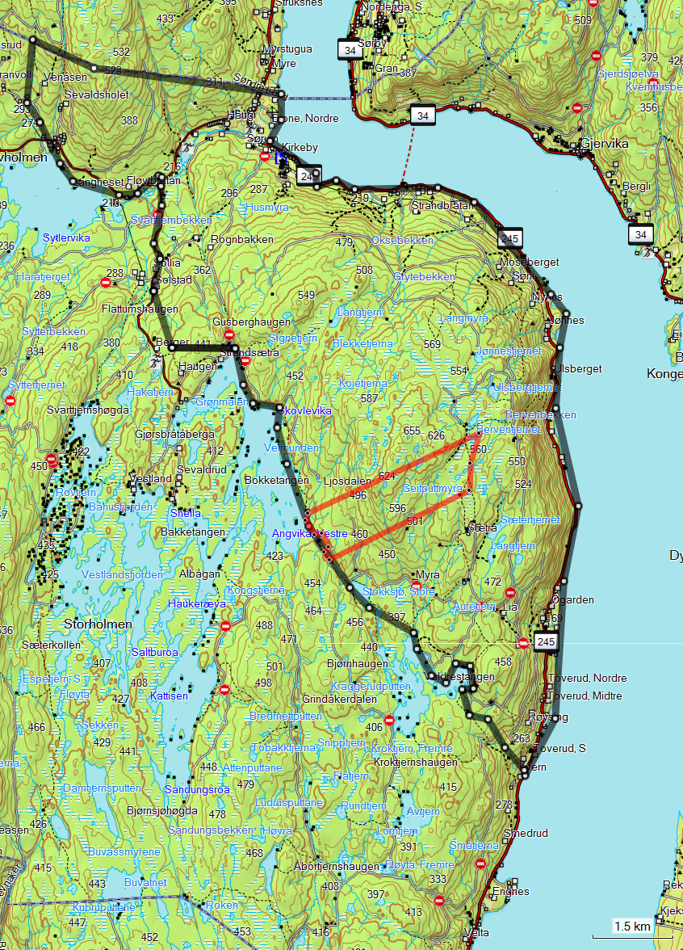
PRIVAT!

